C:\Users\3Newmans\AppData\Local\Microsoft\Windows\Temporary Internet Files\Content.IE5\CE1EF0AD\MC900021628[1].wmfC:\Users\3Newmans\AppData\Local\Microsoft\Windows\Temporary Internet Files\Content.IE5\CE1EF0AD\MC900021628[1].wmfLuther Park

**ChiliFest 2022**

**Sunday, February 6th**

**Join us for a day of fun and fellowship at this fundraiser to support the ministry and mission of Luther Park!**

**Schedule of Events**

**12-4 PM**

Come enjoy a bottomless cup of chili for $7 and vote for your favorite. Hot dogs will be available.

Activities throughout the day include: sledding, games, crafts and much more!

**3:30 PM** Drawing for the chance to win baskets

**Please call ahead if you would like to enter the chili contest or donate a basket.**

**715-859-2215**



***Stay connected with Luther Park and get updated information about ChiliFest!***

[www.lutherpark.org](http://www.lutherpark.org)

Like and follow us on Facebook 

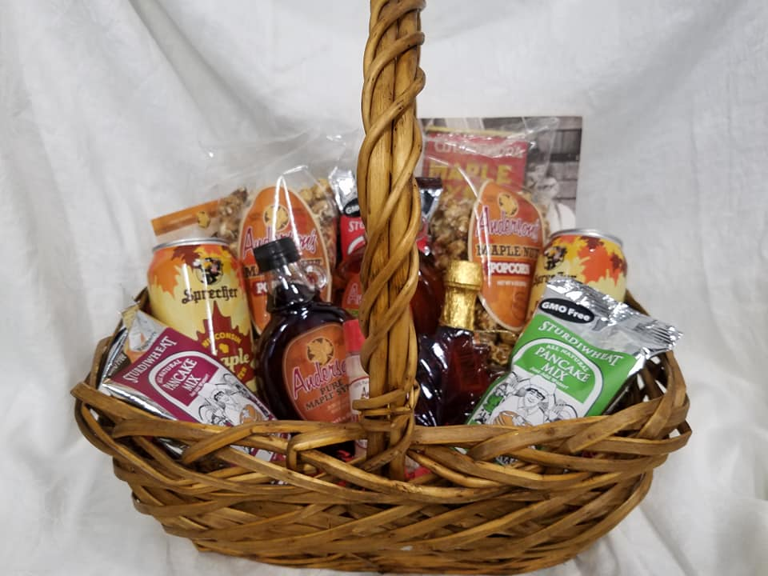

Buy Tickets for your chance to win a basket!

